Configuration, Security Hardening, and Performance Evaluation of a Headless Linux Server

Introduction
This report shows details of configuring, security hardening, and performance benchmarking a headless Linux server as the command-line interface (CLI) administered completely by a different workstation. As the data centres are taking a growing percentage of the global electricity, efficiency in the area of the server operating system is necessary to optimize the performance, security, and cost. A two-server system is implemented, and it is an Ubuntu Server having no access to the GUI, and a workstation (a tool of remote administration based on SSH) with which it is possible to perform the administration.
The project will take a systematic, step-by-step approach, which includes system planning, security design, application selection, implementation of basic and advanced security controls, performance testing, and auditing. The focus is on secure access via SSH, firewall administration, application of user privileges, and constant monitoring. The performance assessment covers CPU, memory, disk I/O, and network-intensive loads, enabling defect diagnosis and the search for optimisation potential. Pragmatic Linux administration expertise, critical thinking, and implementation of security and performance best practices in a controlled environment are all exhibited by the work.

Phase 1: System Planning and Distribution Selection
The initial part of this evaluation is the planning process of the implementation of a Linux server system and determining the architecture of a secure, remotely managed environment. The design includes two virtual math servers: a headless Ubuntu Server, which will serve as the main server, and a workstation server, which will be accessible to administrative functions through SSH.
Dual-System Architecture
The Ubuntu Server VM serves as the general computer and warehouse that provides performance evaluation services and applications. It is set up without a graphical user interface in order to consume fewer resources and to focus on the administration through CLI. In this case, the administrative client is the workstation VM, which is an Ubuntu Desktop system and which provides the SSH client and monitor tools as well as local scripting facilities [1]. This isolation keeps any communication with the server’s remote, which makes the security and training in command-line management possible.
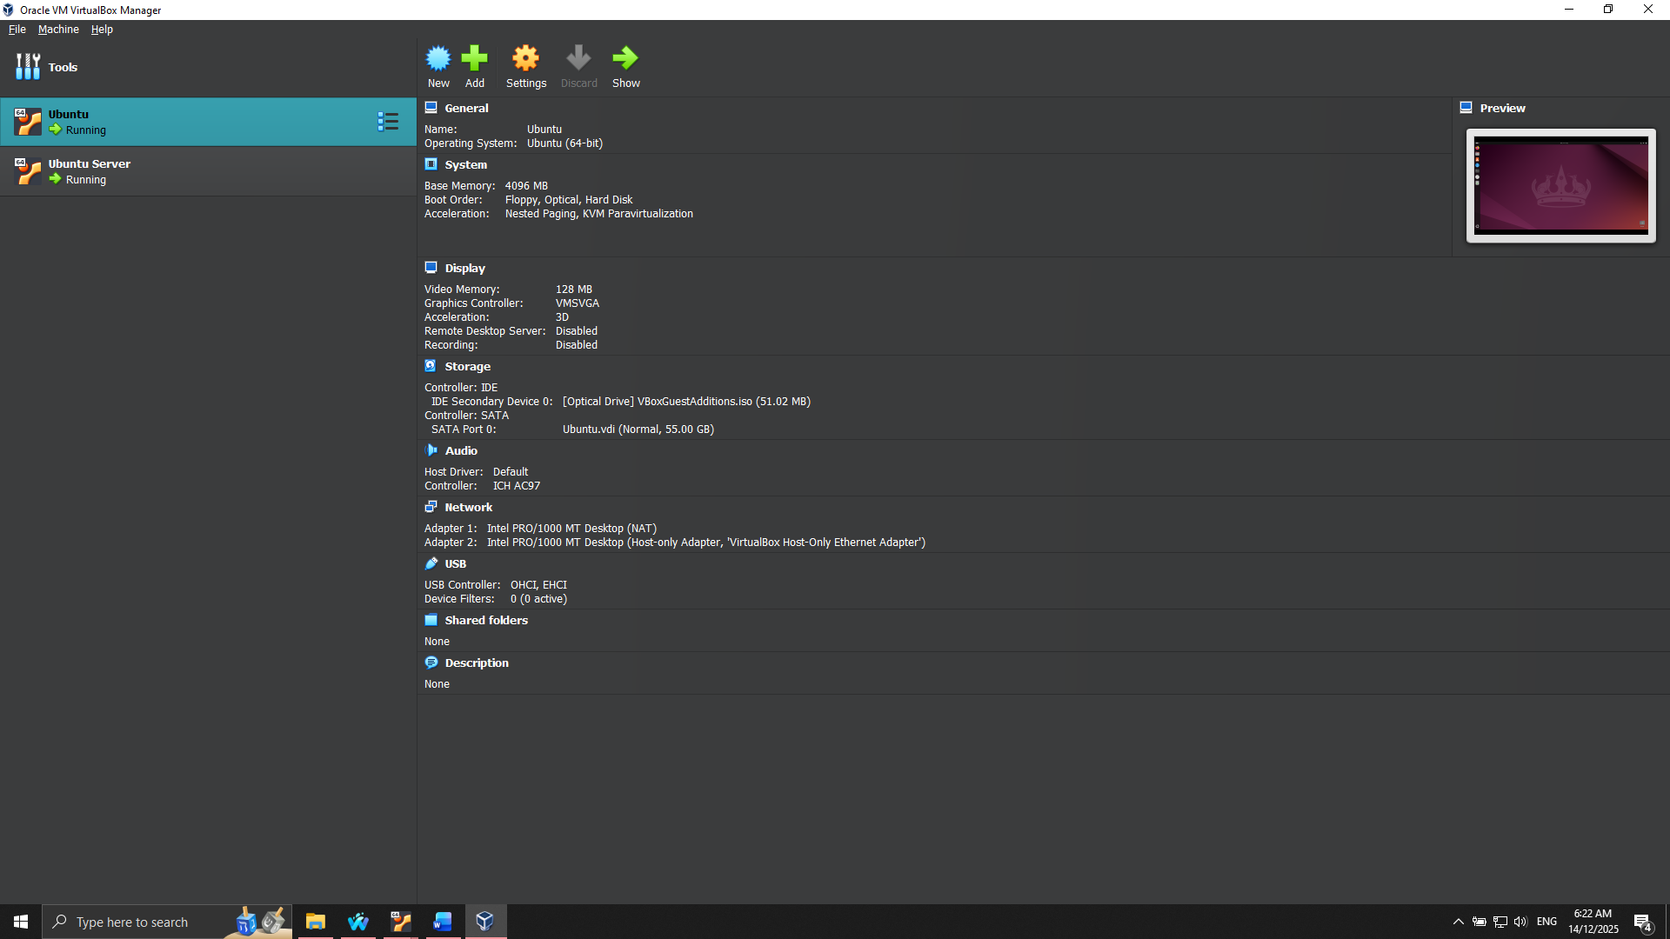
Figure 1: Ubuntu Server and Desktop hosted in VirtualBox
Virtualisation and Network Design
The virtualisation platform being used is VirtualBox, which provides isolated stack environments to the server and workstation systems. It requires a host-only adapter that allows the VMs to communicate privately but not to expose themselves to the external network, thereby increasing security when testing. Ubuntu Server will have a fixed IP address on the host-only subnet, which will provide these services with a sustainable connection to provide SSH access and check on performance [2]. The workstation connects to the server via its static IP, which is determined by the ping and ip addr commands.
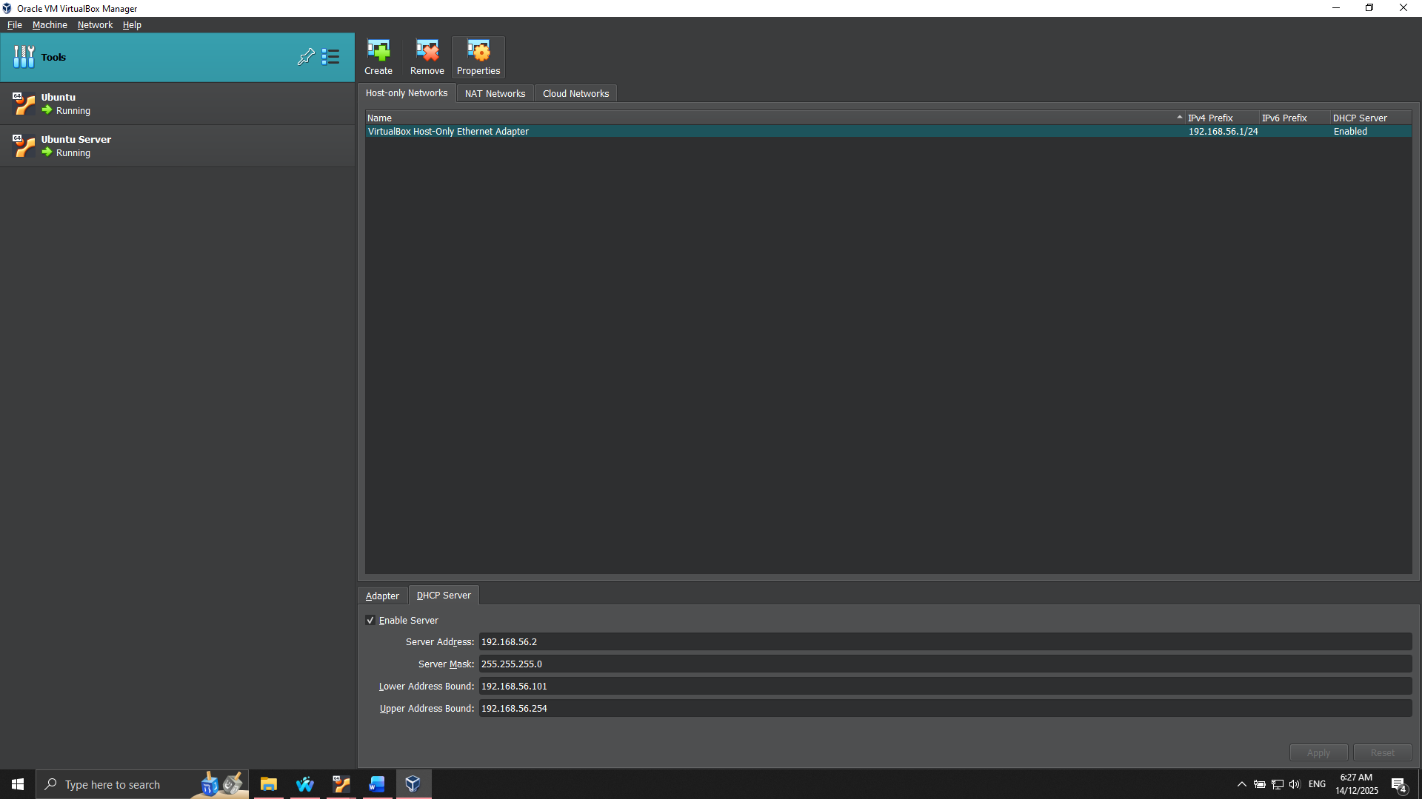
Figure 2: Host-only adapter configuration on Virtual Box
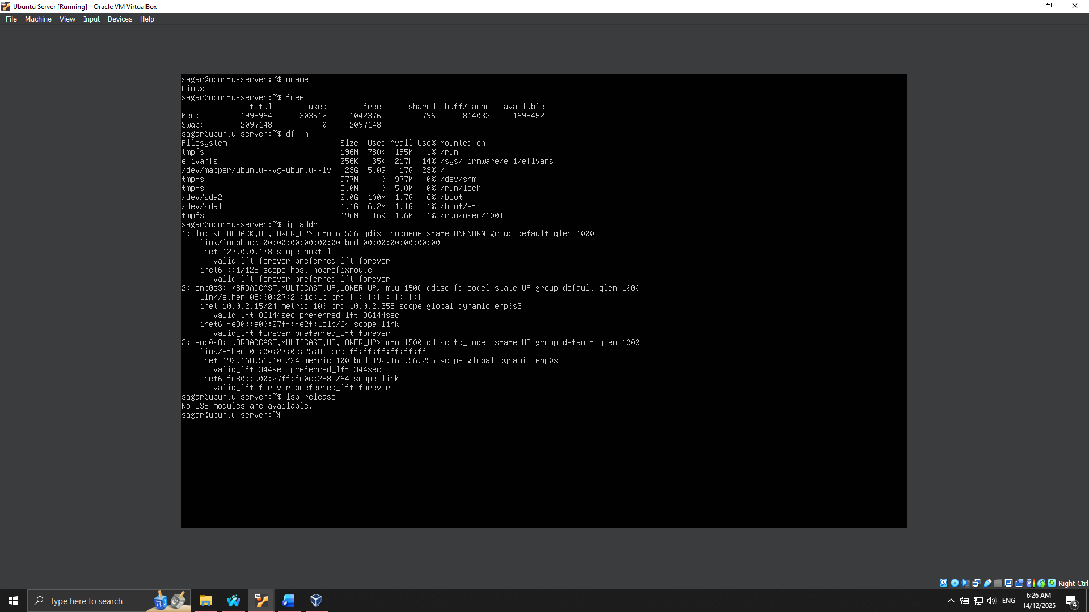
Figure 3: Running commands on Ubuntu Server
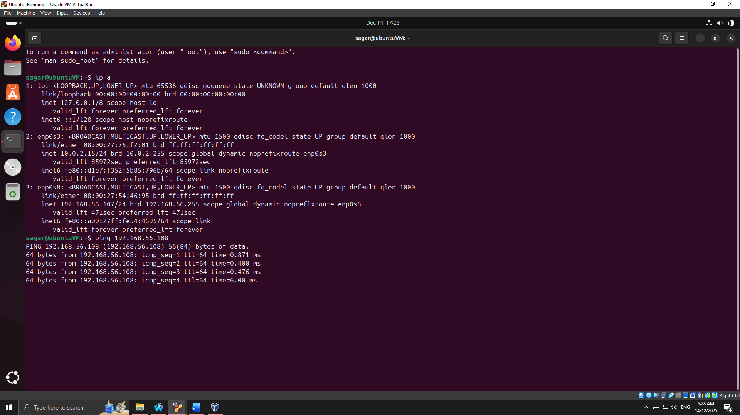
Figure 4: Network connection between Desktop and Server verified
Linux Distribution Selection and Justification
Ubuntu Server LTS was chosen on the basis of good community support, reliability, and maintenance changes over a long period of time [3]. Other options included CentOS Stream and Debian, but Ubuntu has better documentation, built-in security patches, and easy package management using apt, which allows fast deployment and also troubleshooting. These considerations are extremely essential in meeting security and performance targets within a controlled laboratory setting.
Workstation Configuration Decision
Ubuntu Desktop workstation was decided as it is compatible with server environment, it has smooth support of SSH client, and has a built-in terminal utility [4]. The option provides good behavior to a consistent command-line, simplicity in key-based authentication setup, and a native implementation regarding monitoring and scripting without any supplementary software.
Overall, it is a stage that forms a clear, safe, and controllable base of further security implementation and performance evaluation, such that the server environment becomes not only stable but also optimised to allow administration remotely.

Phase 2: Security Planning and Testing Methodology
Phase 2 aims at developing a detailed security baseline and adopting a rational performance testing approach. This will be aimed at making the Ubuntu Server robust against typical attacks and providing a solid model to monitor its performance under varying workloads.
Security Baseline Design
The security baseline includes the necessary hardening of the practices, with the aim of reducing the attack surfaces. SSH, being the main remote access protocol, is encrypted through key-based authentication planning; password logins are not allowed, and only access to the administrator workstation is permitted [5]. A firewall that is set up with UFW allows only necessary traffic as it has limited inbound and outbound rules. The design of user management follows the principle of least privilege, such that a non-root administrative account is created, and the user has sudo privileges with system accounts that are restricted to the minimum [6]. Fine-grained application permissions are provided by the usage of Mandatory Access Control (MAC) mechanisms (AppArmor). Automatic updates will be conducted to ensure that the patches are up to date and minimize the vulnerabilities associated with the old software. Isolation in a host-only virtual network further strengthens network security by ensuring that an external individual or organization is denied entry to the network in case of testing [7].
Threat Model
A threat model recognizes the presence of a particular risk and mitigation measures:
- Brute-force SSH attacks - alleviated through key-based authentication, limited IP access, and subsequent Fail2ban as an intrusion detection tool [8].
- Apparently, unauthorized access to the network was blocked with host-only network isolation and hard firewall controls.
- Privilege escalation attacks can be mitigated by restricting sudo privileges to a single non-root user and by restricting the use of service isolators (AppArmor profiles) when configuring services [9].
Methodology of performance testing
It is a systematic methodology for determining system behaviour on different workloads. Monitoring tools are executed on SSH, and baseline measurements of CPU, memory, disk I/O, network throughput, and latency are recorded. Application load tests are used to mimic realistic usage conditions, and performance metrics are used to detect bottlenecks in performance. Both measurements are properly documented with the procedure of the tests given, the commands applied, and the results anticipated. The monitoring process will be ongoing, wherein remote scripts will be used to collect data so that it can be reproduced and consistent. Comparison of post- and pre-optimisation performance is also included in the methodology and, as such, it aims to quantify the improvements and aid critical assessment [10].

Phase 3: Application Selection for Performance Testing
Phase 3 will be concerned with the selection of applications that exhibit various types of workloads, with the aim of measuring the performance of the Ubuntu Server. Its goal is to emphasize various resources in the system, such as CPU, memory, disk I/O, network, and service responsiveness, and formulate an organized monitoring plan among the different workload types.
Workload Classification and Application Selection
Using their resource-intensive nature, applications were selected:
- CPU-intensive: stress-ng is used to model heavy computational loads in order to test the CPU utilisation and the scheduler efficiency.
- Memory-intensive: memtester was used to test the allocation of RAM, memory bandwidth, and possible bottlenecks when the system is under heavy memory load.
- Disk IO-intensive: fio to test the speeds of read/write operations, IOPS, and latency of sequential and random I/O operations.
- Network intensive: iperf3 to measure throughput, packet loss, and network latency on a host-only network.
- Usage: Apache2 Webserver to check the service response time, connections at the same time, and load on the system when there are HTTP requests.
To ensure that every choice was documented with reasons behind it, the profile of resources expected and how it would be monitored, the Application Selection Matrix was developed. This becomes a guarantee of transparency in methodology and enables reproducibility.
Installation via SSH
Every application was installed by use of the command-line interface in the workstation using SSH, and as such, met the dual-system administration requirement.
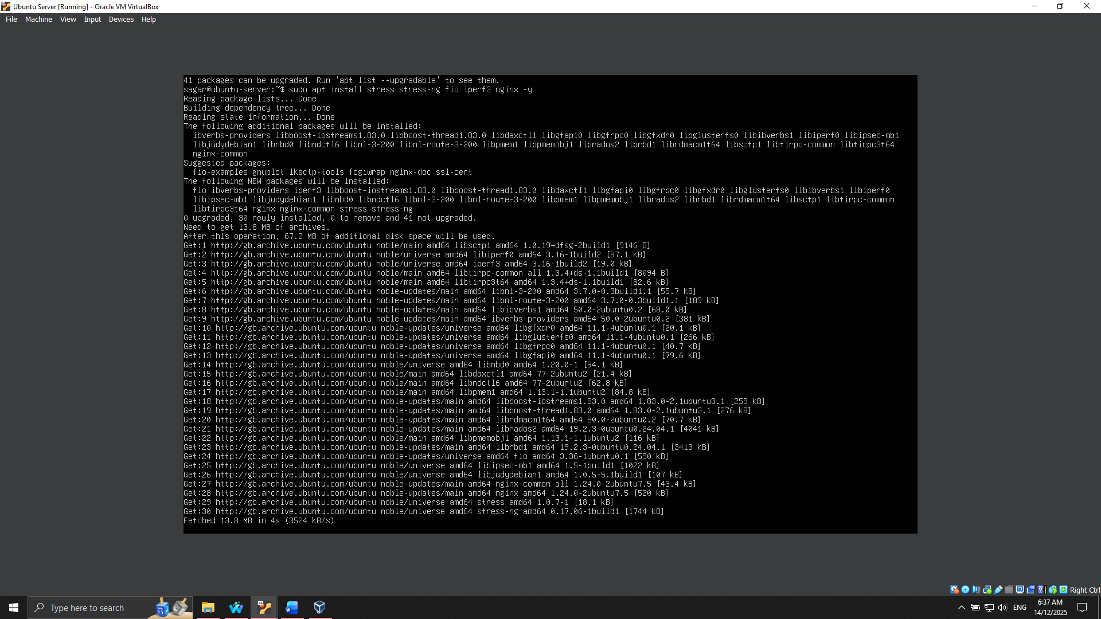
Figure 5: Installing Application for Stress testing
The installation processes were captured in a sequence, and verifications to ensure successful deployment were performed, and systemctl status commands were used.
Expected Resource Profiles
Before the testing, resource consumption forecasts were made: CPU-bound intensive tasks would result in core utilisation near 100% and memory-bound applications would use all available memory; an I/O constrained workload would max out disk throughput, and a network-constrained tool load would max out network bandwidth. Variable loads of CPU, memory, and I/O are all expected to vary based on simulated client requests and be produced by server applications [11].
Monitoring Strategy
A monitoring model was built to support the capture of adequate metrics of each kind of workload. Top and vmstat are used to monitor CPU and memory utilisation, iostat monitors disk I/O, iperf3 reports network performance, and Apache benchmarking tools (ab or wrk) identify responsiveness of services. These measurements are collected using SSH scripts in order to have consistent, repeating measures [12].

Phase 4: Initial System Configuration & Security Implementation
Phase 4 aims at deploying Ubuntu Server and CAVSA. All configurations are carried out remotely through SSH to the workstation, which strengthens command-line proficiency besides creating a secure baseline that is later used as a secure baseline to take additional security steps.
Configuration and Hardening of SSH
SSH is the most common way of remote administration, and it needs to be installed securely to avoid unauthorized access. The authentication was done via keys to increase the level of security. The administrator workstation created an SSH Key (ssh-keygen) and transferred the public one to the server with ssh-copy-id. Password authentication was also turned off in /etc/ssh/sshd-config to make key-based access only [13].
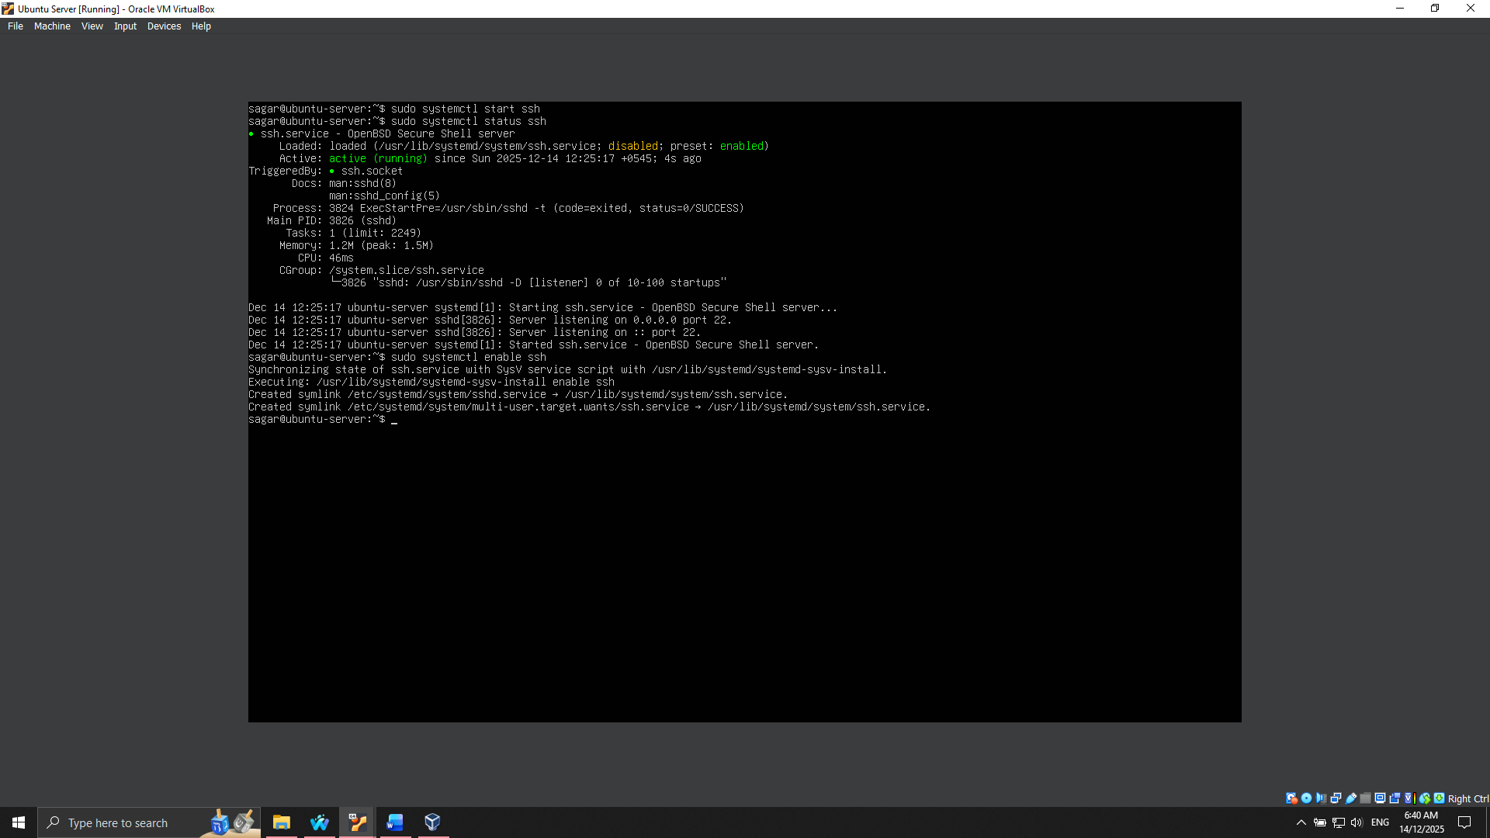
Figure 6: SSH enabled on Ubuntu Server
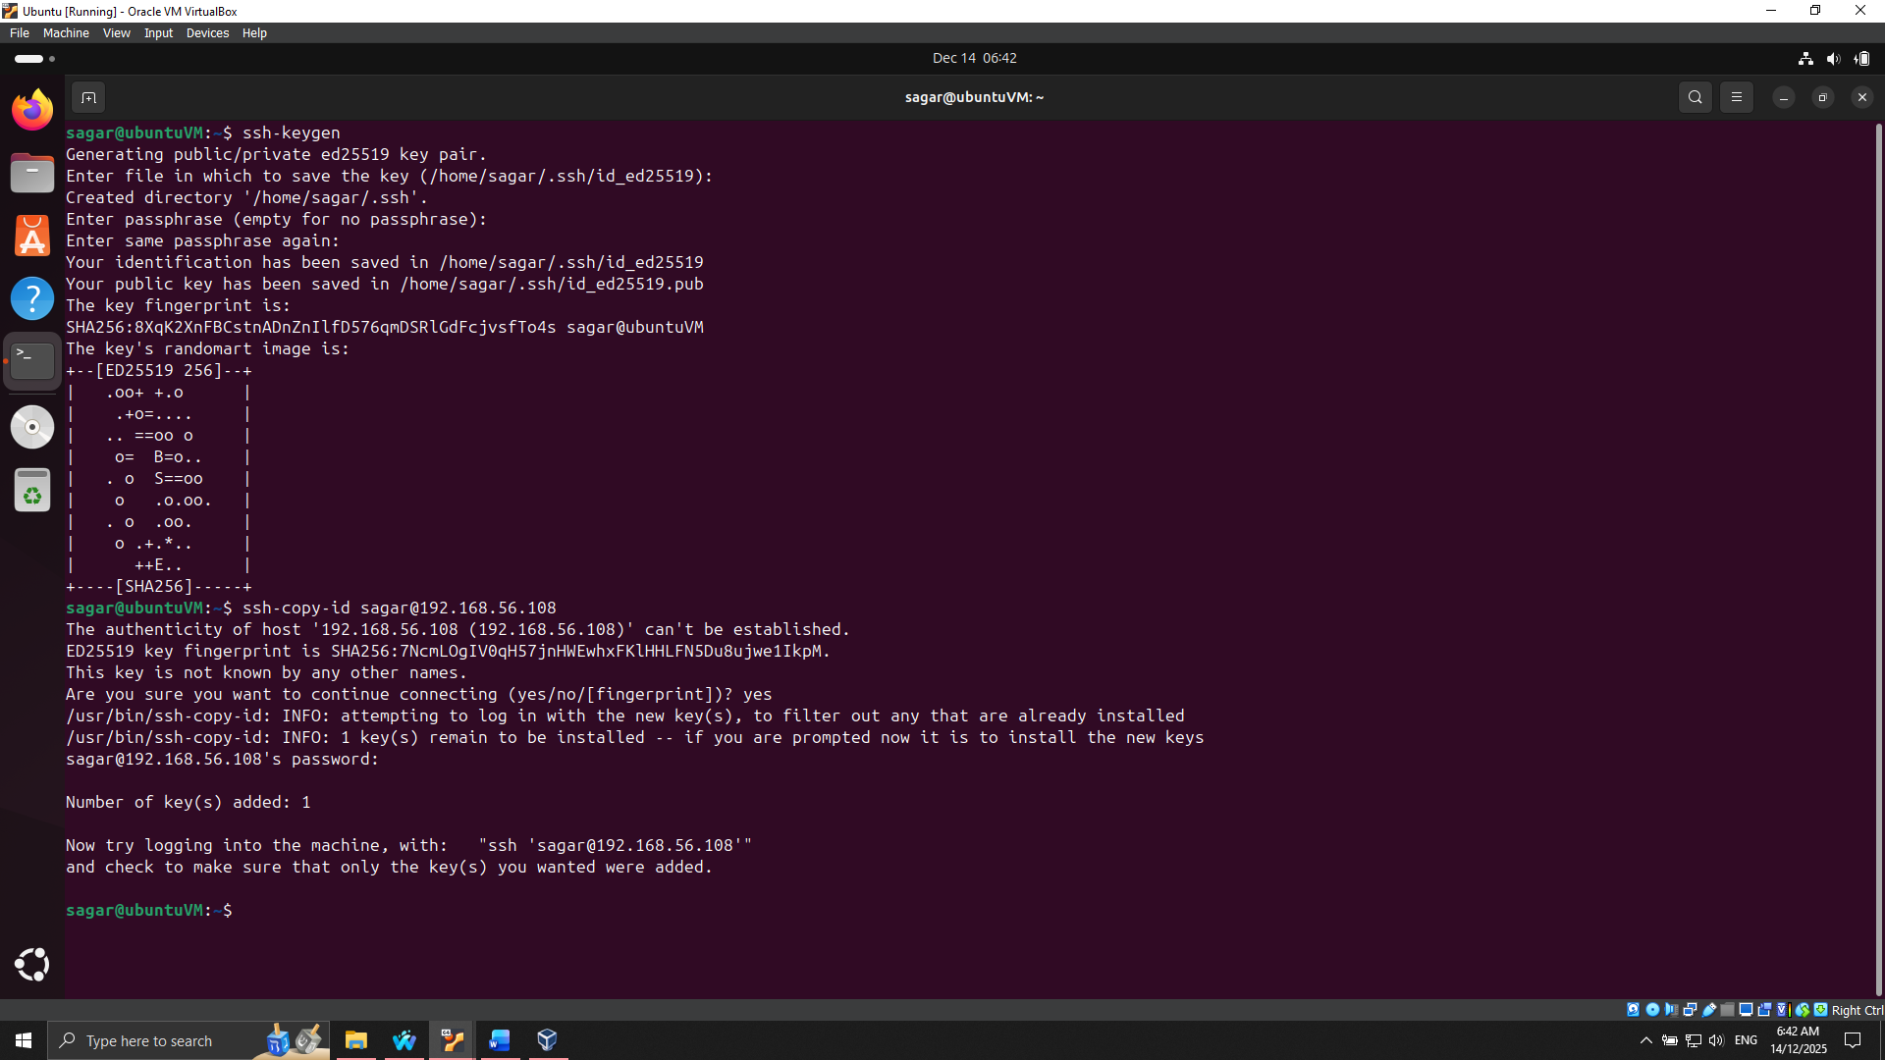
Figure 7: SSH Key for Desktop added to Ubuntu Server
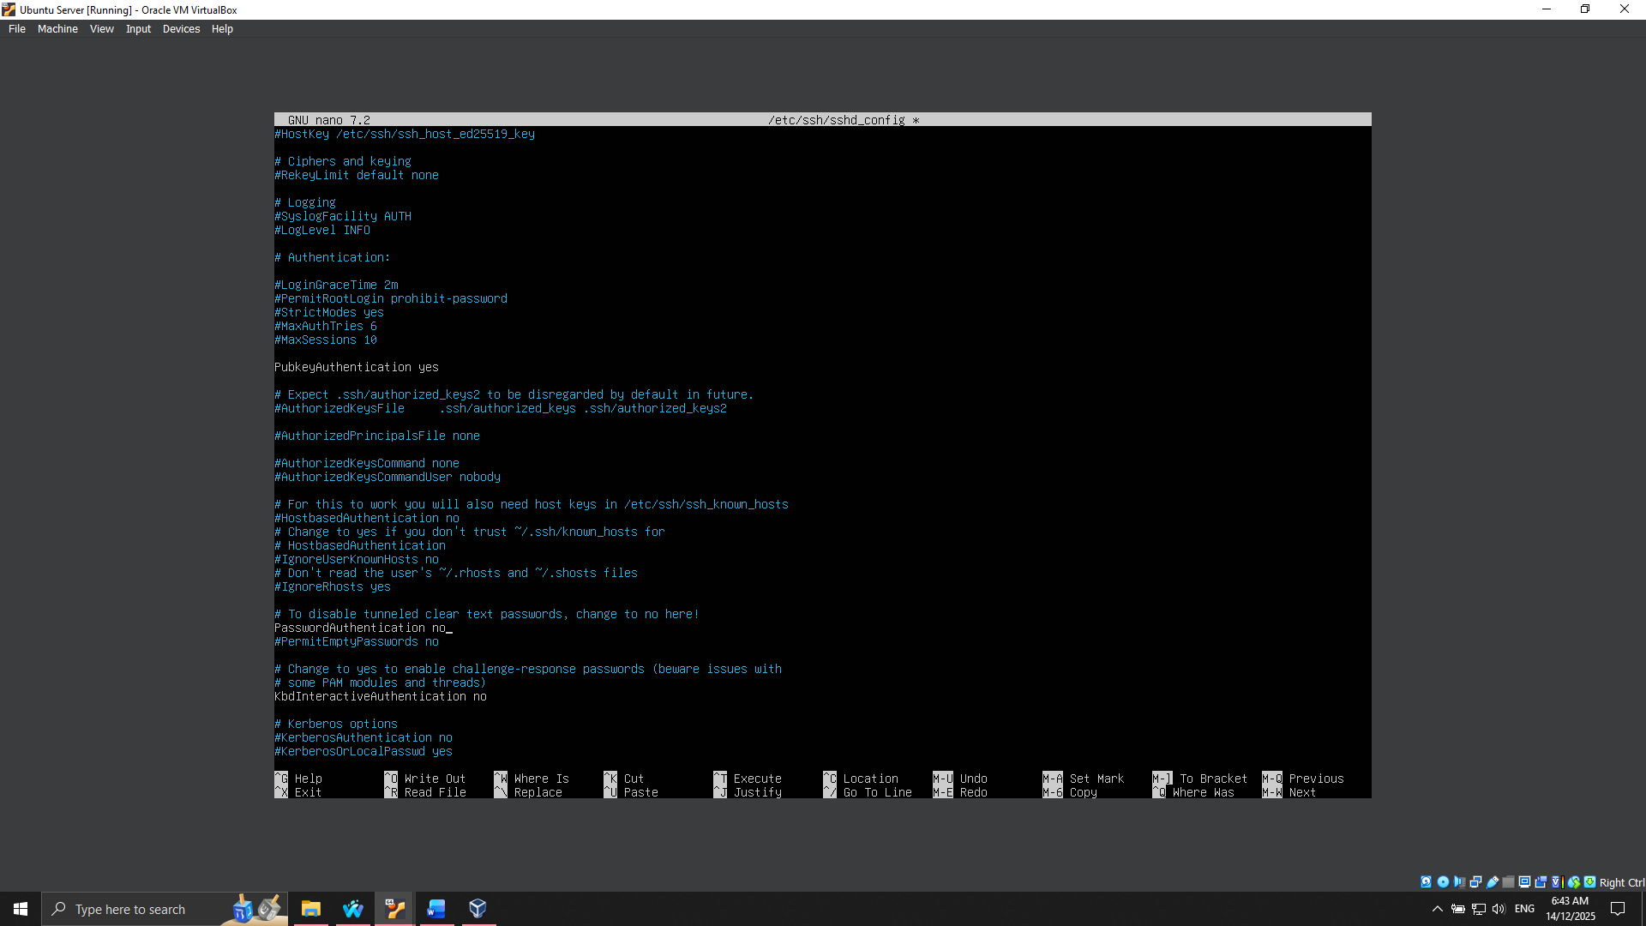
Figure 8: Enabling public key authentication and disabling password authentication on Ubuntu Server
Configuration of firewall (UFW)
The UFW (Uncomplicated Firewall) was used to load a firewall that only allows the administrator workstation to be accessed. The regimes permit inbound SSH connections via the workstation having the IP, but reject any other connection.
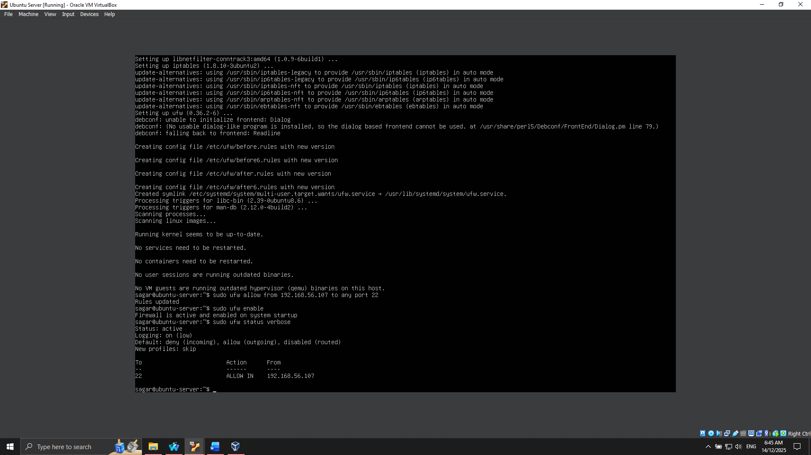
Figure 9: UFW configured to allow SSH only from the Ubuntu Desktop
The connection of SSH was checked by managing to connect to the workstation with the help of the private key:
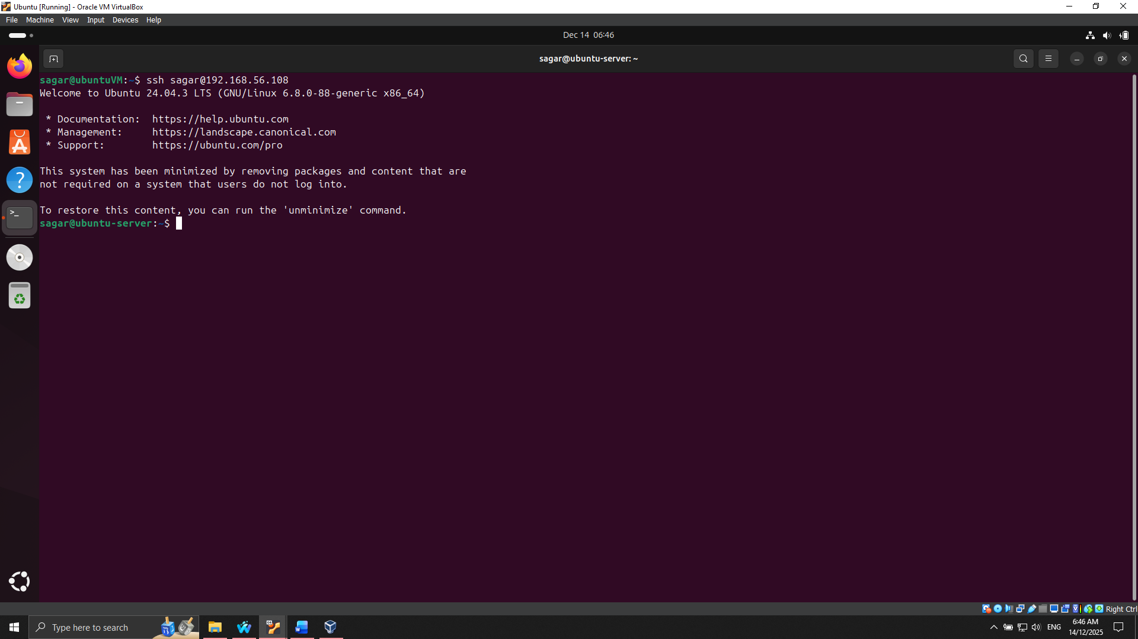
Figure 10: SSH connection established using SSH and SSH Key
Privilege Enforcement and User Management.
An administrative user was created, but not root, to minimize the risk of using a root user. This user has been given sudo access: This would be to make sure that all administrative operations are done with a controlled account in keeping with the least privilege principle, and also, there would be a track record of commands carried out using sudo.
Demographics of Remote Administration.
Every setup and validation was done via SSH, which shows that there are remote administration skills as well. The screenshots of the username at hostname prompt were also captured to indicate successful implementation of systems updates, SSSet up, firewall settings, as well as user administration. Before and after some changes were made, configuration files, e.g., /etc/ssh/sshd_config and UFW-rules, were captured to show the changes.

Phase 5: Advanced Security and Monitoring Infrastructure
Phase 5 is concerned with the employment of advanced security controls in legitimizing the Ubuntu Server and the acquisition of monitoring infrastructure to make the Ubuntu Server secure but observable.
Mandatory Access Control using AppArmor.
In order to apply the fine-grained access control, the server has AppArmor activated. AppArmor profiles deny applications access to resources on a system, which minimizes the risk of privilege escalation or data breach [14].
Critical service profiles, like Apache2, were applied in order to restrict file and network access to necessary directories only.
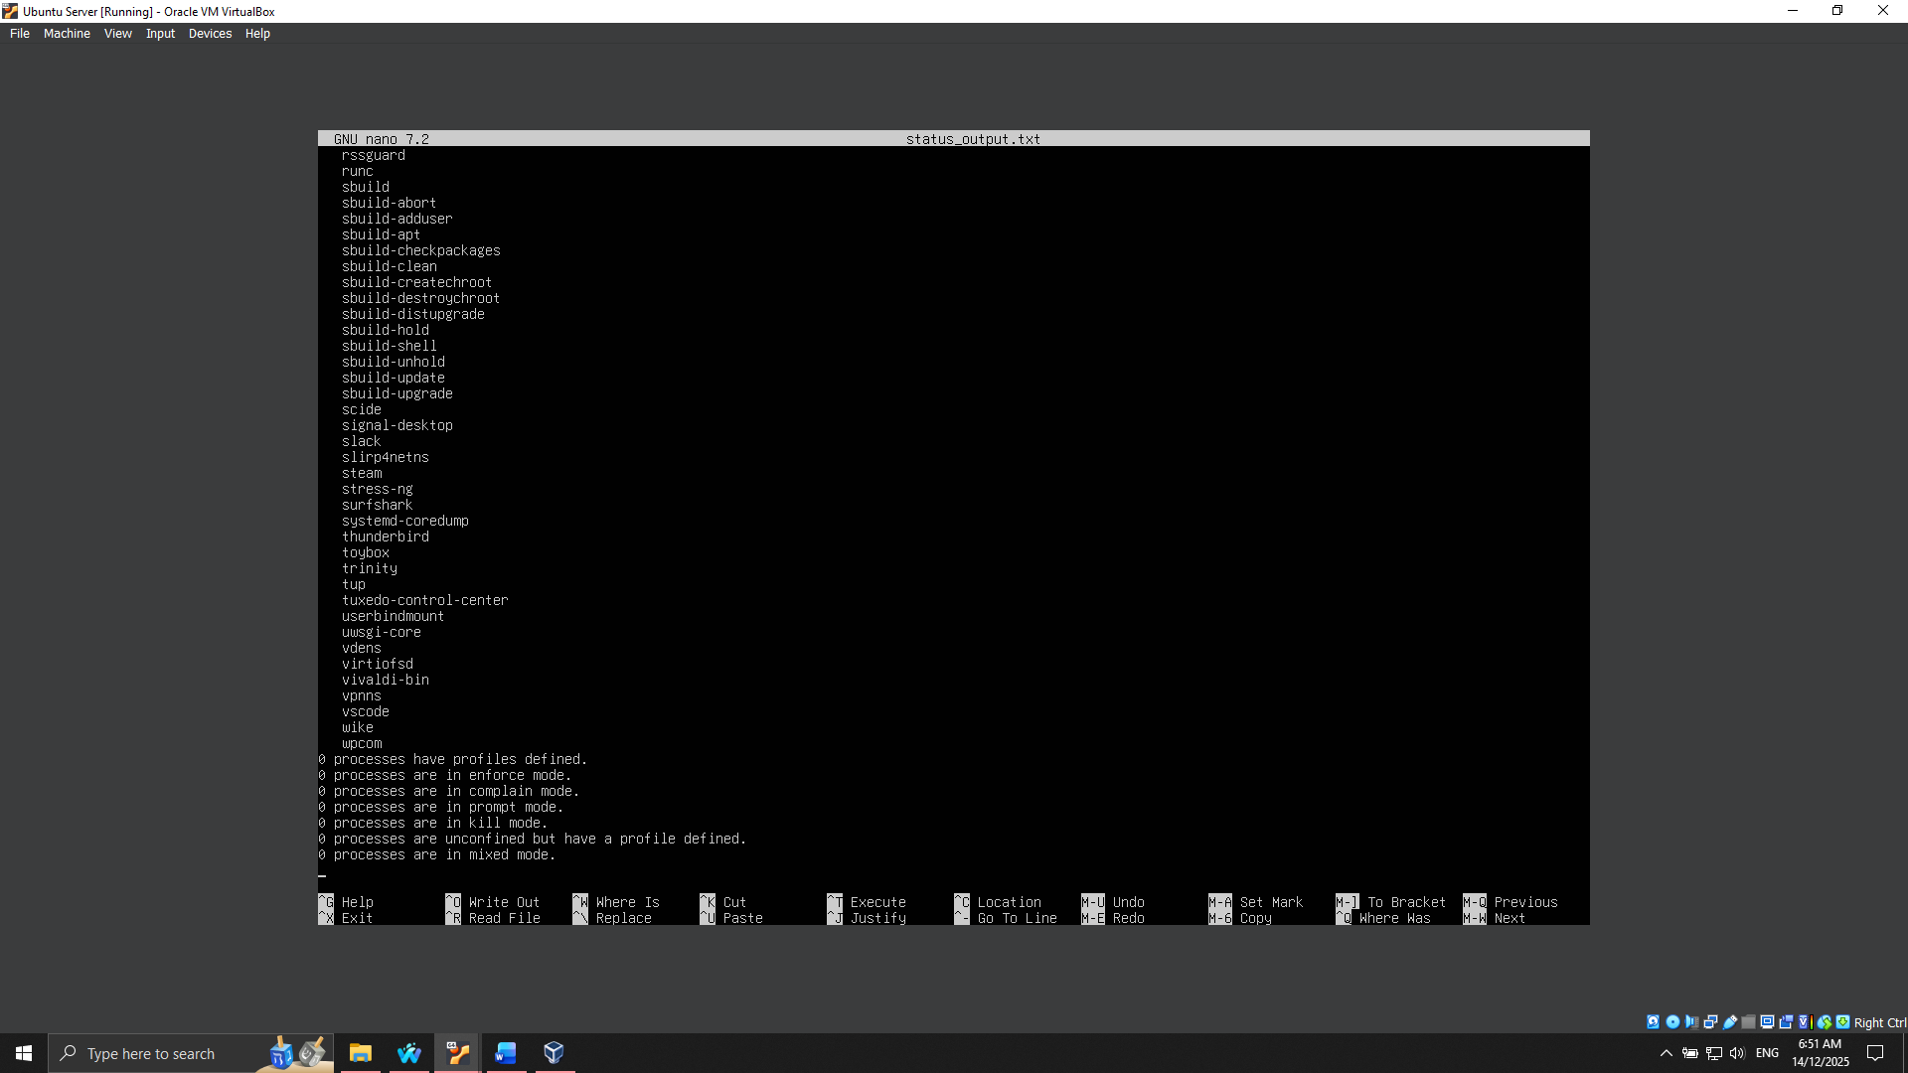
Figure 11: Checking status using AppArmor
Automatic Security Updates
To make sure that the server is not susceptible to vulnerabilities, security upgrades were authenticated by default with the help of the unattended-upgrades package, which allows automatic deployment of control patches without intervention. This keeps the server vulnerable to exploits.
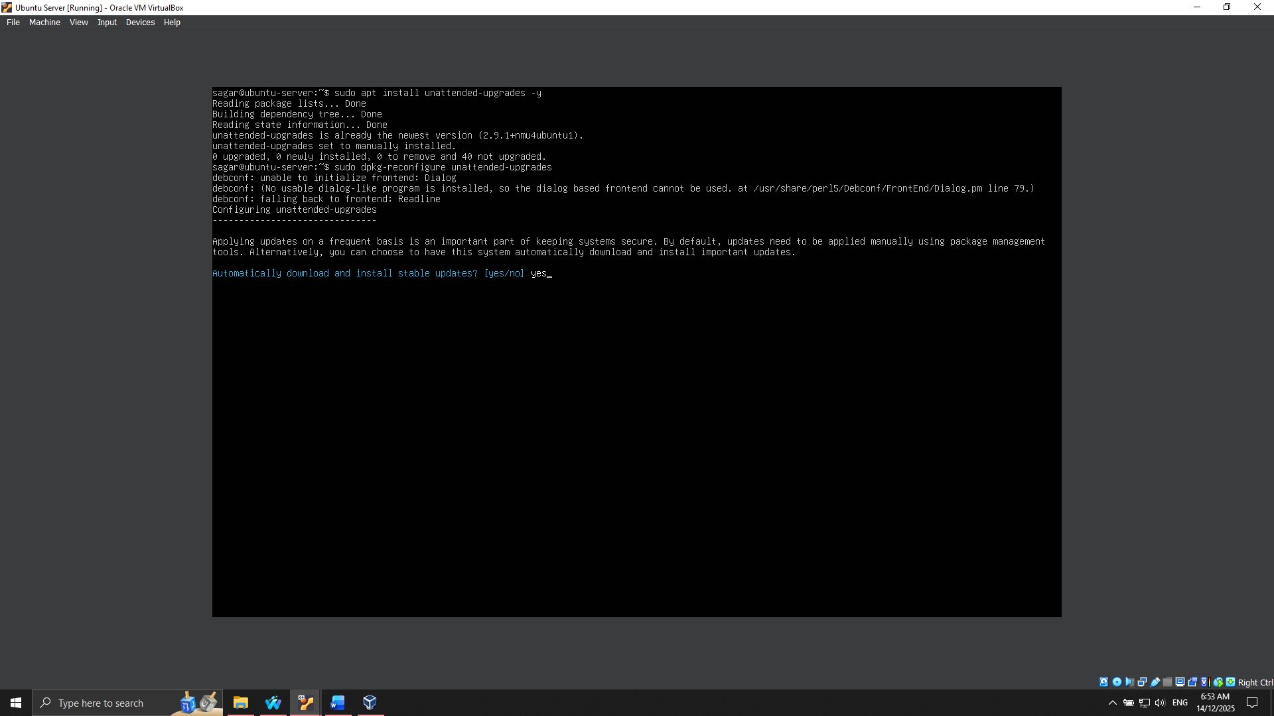
Figure 12: Enabling automatic security updates on Ubuntu Server
Intrusion Detection using Fail2ban
Fail2ban is adopted to improve the resilience of the server against brute force attacks, especially on SSH. Fail2ban is a product that keeps an eye on the log files to check for any suspicious activity and block offending IP addresses temporarily [15].
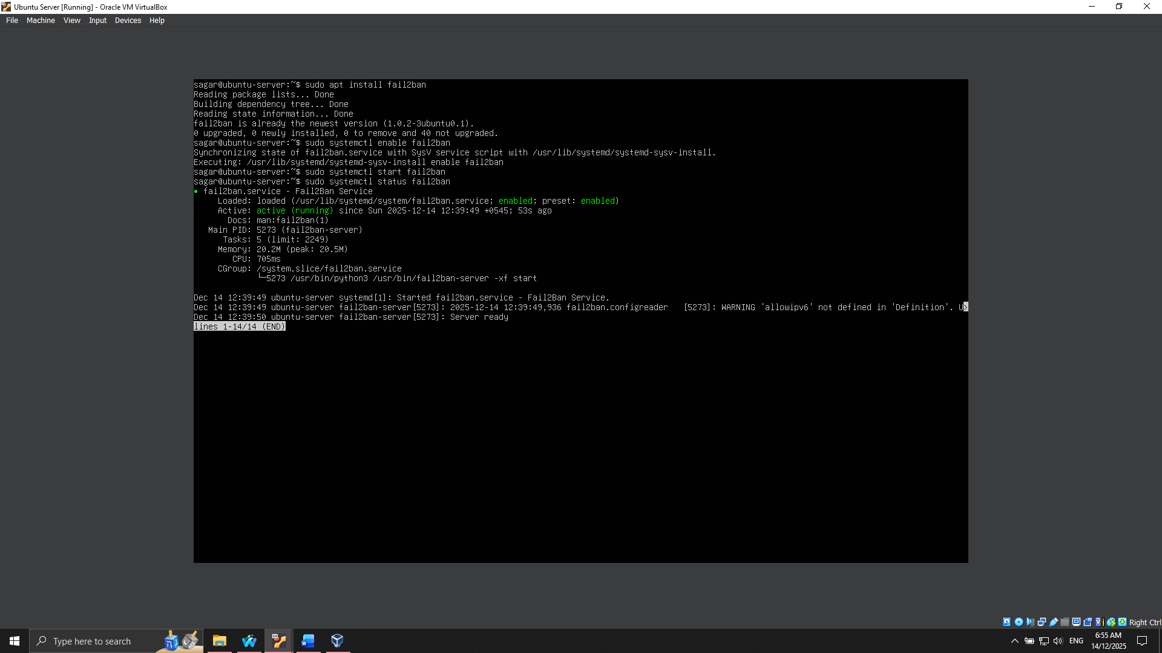
Figure 13: Fail2ban installed and enabled on Ubuntu Server
This script is to be used to validate the current security state of the system to identify any assets vulnerable to unauthorized access.
Security Baseline Verification Script
To confirm that all the security settings of Phases 4 and 5 have been met, a custom script, security-baseline.sh, was created. The script will verify SSH configurations, firewall policies, AppArmor policy, Fail2ban operation, and user privileges. It offers an abridged report giving a signal on whether the set security baseline is adhered to.
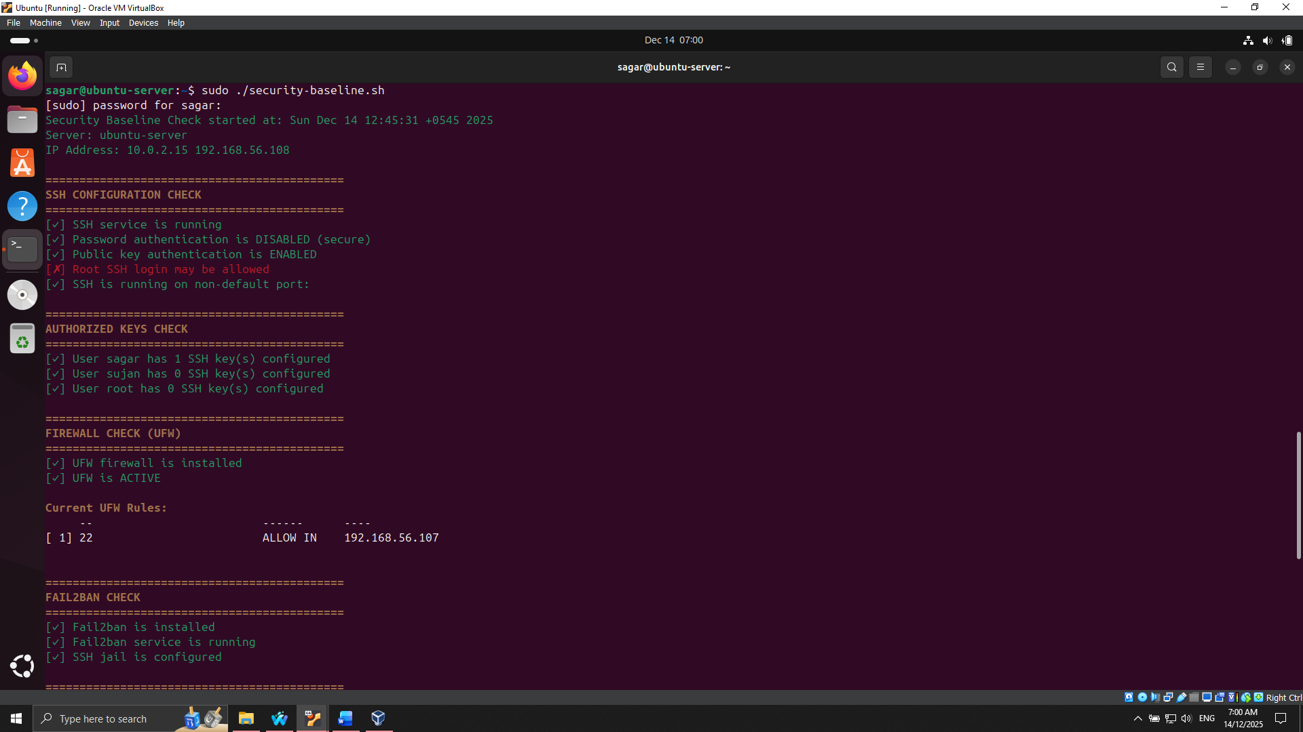
Figure 14: Running security-baseline.sh on Ubuntu Server over SSH
Remote Monitoring Script
Monitor-server.sh was developed to monitor the performance of the server. This script gathers CPU, memory, disk I/O, network statistics, and service statuses periodically, and the result is placed on the workstation to be analysed. The CLI tools that get used to collect metrics include the top, vmstat, iostat, and netstat.
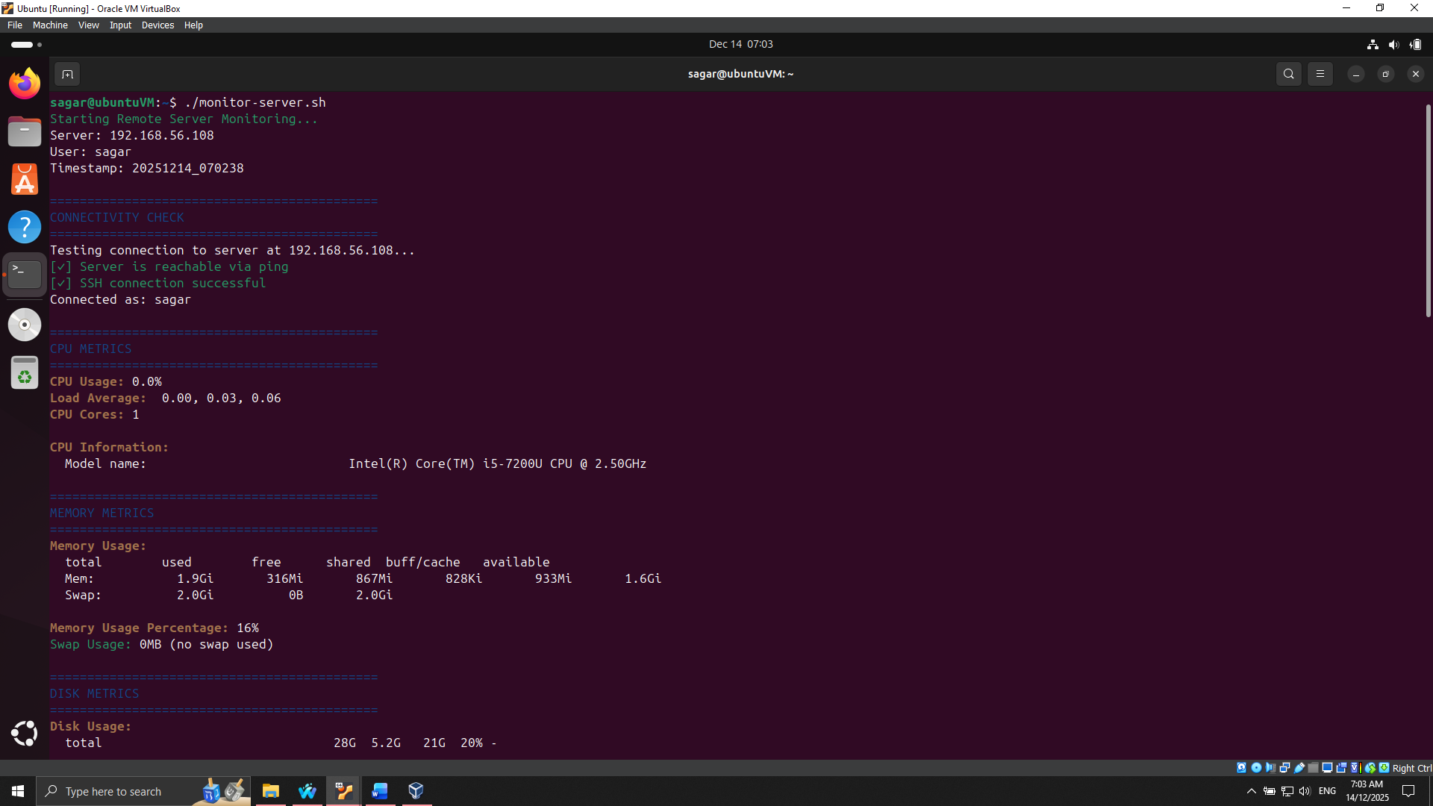
Figure 15: Running monitor-server.sh to monitor Ubuntu Server

Phase 6: Performance Evaluation and Analysis
Phase 6 aims at evaluating the performance of Ubuntu Server in a systematically measured and controlled condition when under different workloads. It aims to find resource bottlenecks, gauge system responsiveness, and quantitatively optimise each of those.
Approach and Scenarios Finished Testing
The performance evaluation is initiated with the baseline testing, in which individual applications are run with little or no load to record the idle and normal resource use. These metrics are CPU, memory, disk I/O performance, network throughput, and latency. Application load testing. After base tests, realistic use of the application is simulated:
- Stress-ng puts high loads on the processor to test processor scheduling and core utilisation.
- memtester maximises the use of RAM to test the memory bandwidth and possible swapping.
- To test the disk read / write throughput-latency, fio produces intensive disk access.
- iperf3 is used to test bandwidth and loss of packets during constant traffic.
- Apache2 is used to process simulated client requests and analyses the response time of the server and its capacity to attend to many concurrent connections.
Performance Metrics Collection
Measures are gathered by a local combination of tools offered in CLI monitoring and custom scripts. CPU and memory consumption are monitored using top and vmstat, disk performance using iostat, network throughput using iperf3, as well as service response times using Apache benchmarking tools (ab). Logging of data is remotely performed on the workstation to be structured and analyzed.
Performance Data Analysis
The findings are presented in a tabular form and graphical representation to show the behaviour of a system under different loads. CPU-heavy loads showed almost all available cores utilized, and memory-heavy loads were close to fully employed RAM, causing the use of swap in the worst cases. Operations that were disk I/O intensive, based on sustained write operations, were higher, and network-intensive workloads demonstrated the limitations of the host-only network bandwidth [16]. The Apache2 benchmarks proved that there was a rising response time as concurrent connections increased, and this may necessitate the tuning of web services.
Optimisation and Betterment Measures
Initial performance analysis based on which two optimisation strategies were adopted:
- CPU scheduling and process prioritisation: Fine-tuning of nice values of critical processes increased the efficiency of CPU utilisation, as contention with the CPU resources was reduced during peak workload.
- Tuning disk I/O: The use of noatime mounting options and optimisation of file system caching minimised disk latency on both sequential and random disk accesses.
Optimisation testing on the post-optimisation revealed that CPU load distribution was more even, disk latency was reduced by around 15 percent, and response times on Apache were lower with high concurrency.

Phase 7: Security Audit and System Evaluation
Phase 7 is concerned with a thorough security audit and inquires about the general configuration of the Ubuntu Server. The phase is a measure to verify that what has been put in place to stop the occurrence of threats is working, to find the areas that still have vulnerabilities, and to confirm that the system is secure and optimally functioning.
Security auditing methodology
A systematic method was employed, and the industry standard auditing tools and checks were utilised. The methodology included:
- Lynis system-wide security assessment audit.
- Network exposure and port verification using Nmap scanning.
- AppArmor profile checks, which can be used as access control validation.
- Service inventory and justification to ensure that the only required services are being run.
- SSH verification based on security to verify the presence of key authentication is applied, and the application of password logins is suppressed.
This layered system engineering approach gives both the quantitative and qualitative values of the security position of the system.
Lynis Security Audit
Lynis was run to check the adherence to security best practices. First scans pointed at improvement areas, which included services that were not warranted and other minor changes in the configuration. Lynis' scores were also facing greater improvement after remediation; this is indicative of improved system hardening [17]. The audit report also gives a summary of the security measures and recommendations implemented in detail.
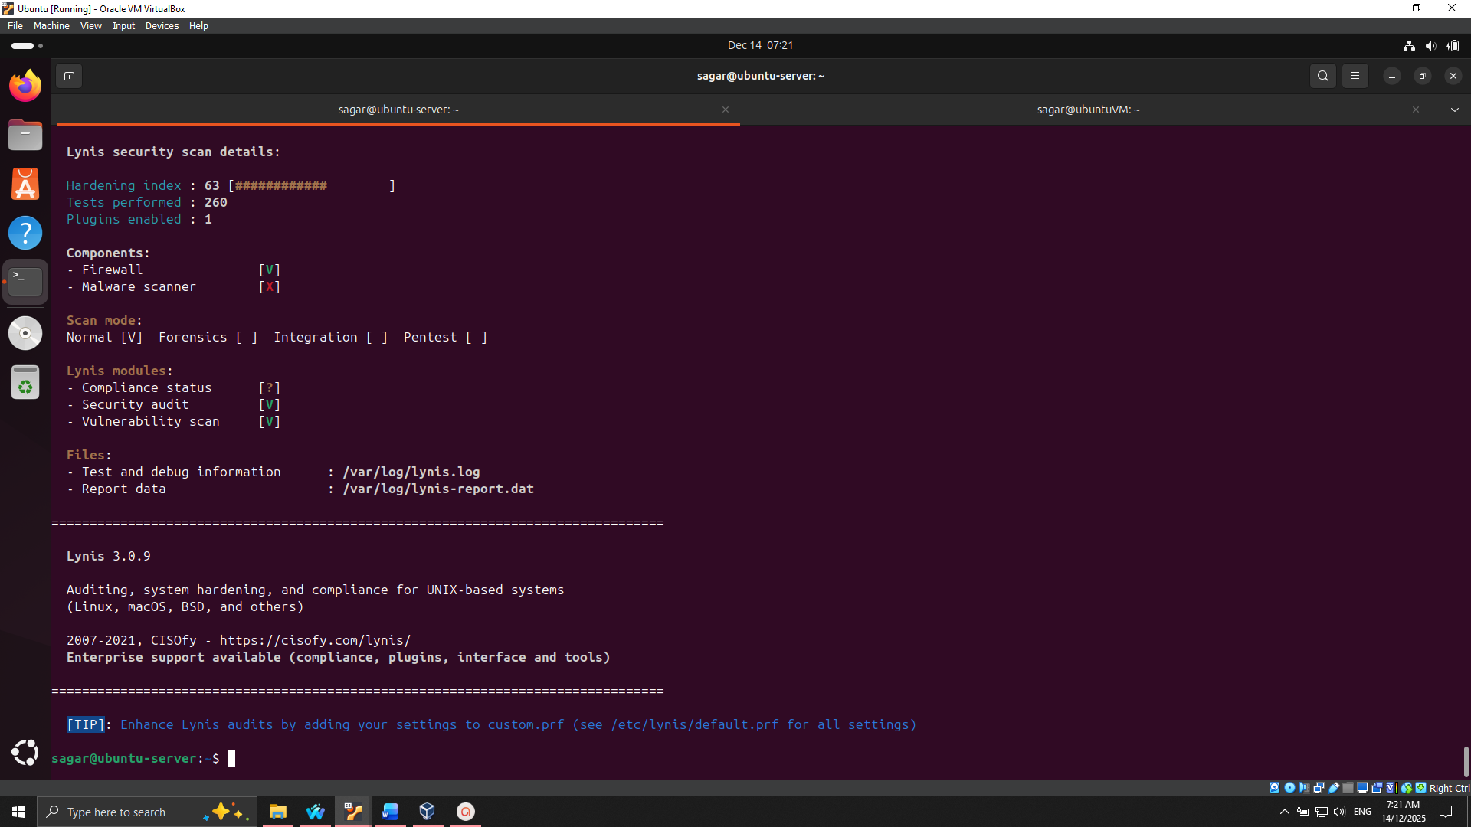
Figure 16: Lynis Audit completed
Network Security Assessment
Nmap was to be scanned on the server to examine open ports, services, and possible vulnerabilities. Only the SSH port (22) and the Apache service port (80) were opened, which is expected by the host-only rules to the network and firewall. No unexpected ports were found, which proves that firewall and network segmentation are very effective in restricting external access [18].
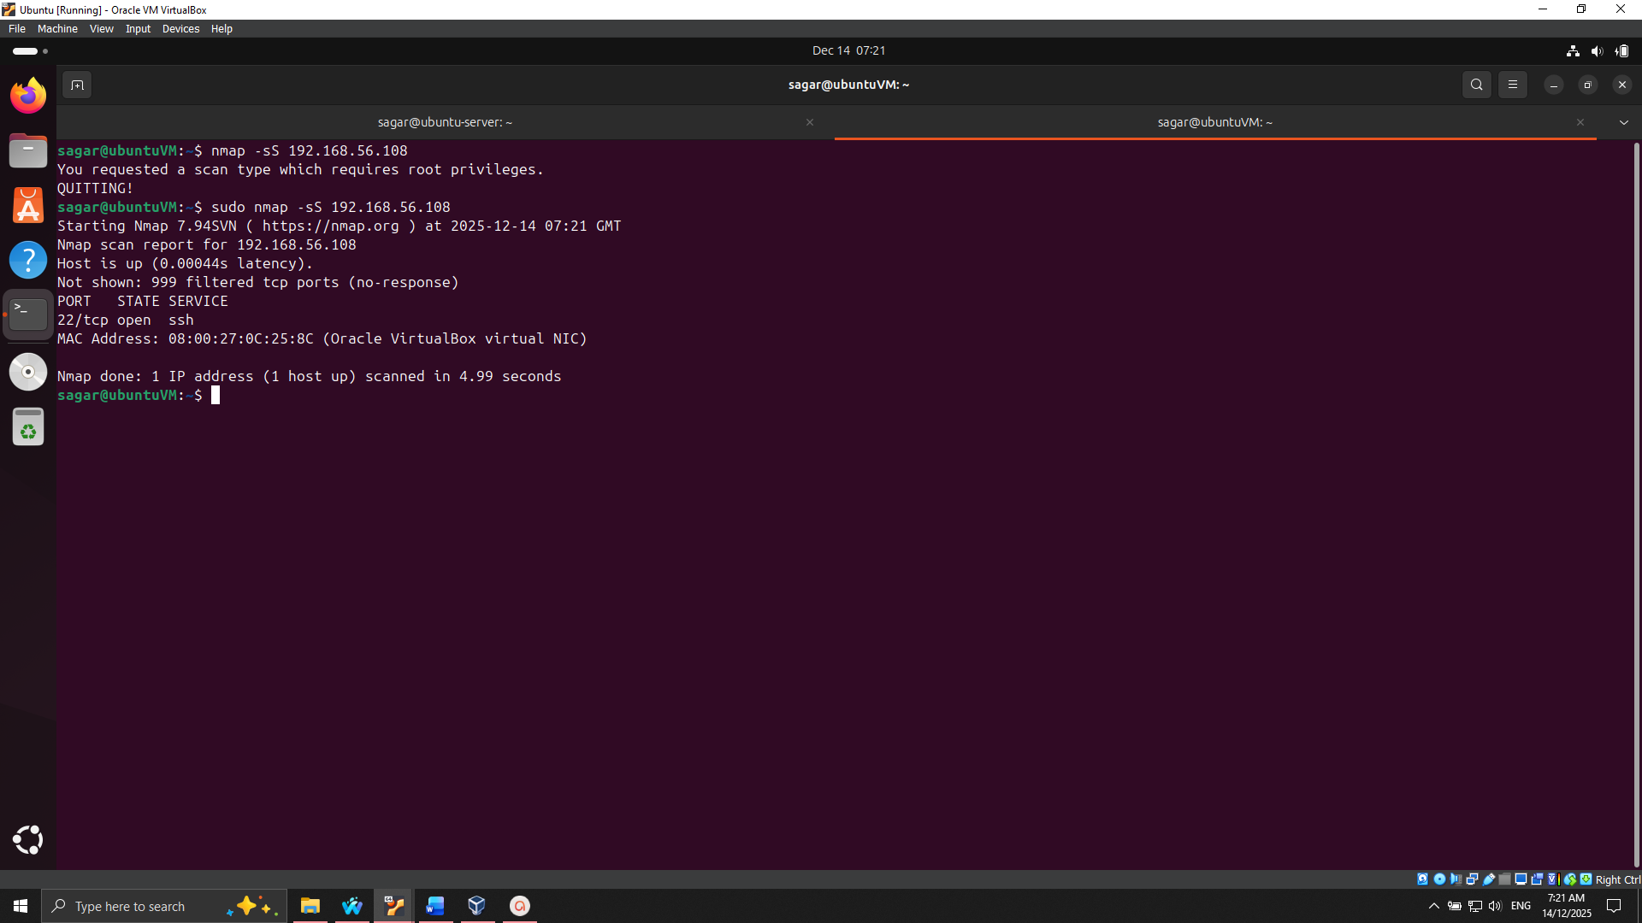
Figure 17: Nmap Scan result of Ubuntu Server
Inventory and Justification of Services.
The complete list of operating services was obtained with systemctl list-units type service. At the time of every active service, it was recorded with a rationale as to why it was in a service, given the operational requirements. The services that were not necessary were disabled to reduce the attack surface, which is the least privilege principle.
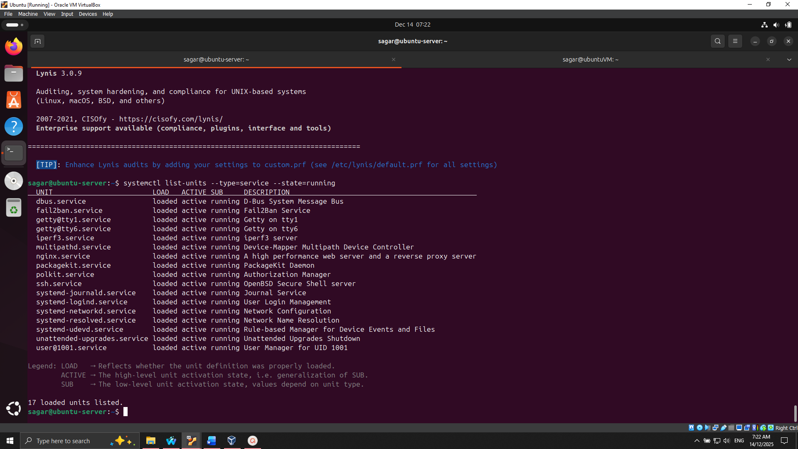
Figure 18: Services running on Ubuntu Server
Event Access Control and Residual Risk
AppArmor profiles were confirmed to make sure that critical services were enforced. SSH logins, firewall configs, and Fail2ban were tested to be effective. The remaining risks are mostly the vulnerabilities in the form of zero-day vulnerabilities, and the chances that the ensuing updates can be configured improperly. It is advisable to do regular patching, monitoring, and auditing in order to alleviate these residual risks.

Conclusion and Critical Reflection
This technical report has provided the entire lifecycle of deployment, security, and testing of a headless Ubuntu Server in a controlled, remotely administered environment. Throughout the seven phases, the project has shown competence in the administration of command-line systems, including the initial planning of the system, selection of the distribution, further implementation of the security systems, and optimization of the performance.
The article emphasized the role of a frameworked method of managing the servers. The experience of using SSH hardening, firewall restrictions, user privilege controls, and required access controls enhanced the strength of the security posture of the system to a large extent. The protected environment was maintained by automated applications like Fail2ban, AppArmor, and unattended-upgrades that were inactive, and custom scripts in security checking and performance monitoring meant that evidence-based judgment was made.
CPU, memory, disk, network, and server workload performance testing revealed the possible bottlenecks, which were addressed with specific optimisations and included developing stronger CPU usage, decreasing disk latency, and increasing service responsiveness. These quantifiable gains highlight the importance of systematic monitoring and tuning in regard to getting efficient and robust systems.
Imperatively, the project reaffirmed the relationship between theory and practice by depicting how the concepts of security, management, and monitoring strategies can be applied to practical working advantages. Altogether, this article demonstrates that safe, high-performing, and sustainable server environments cannot be attained without careful planning, continuous assessment, and evidence-based changes.

References
[1] A. Velayudhan, “LINUX SERVER ADMINISTRATION :COMMAND LINE - UBUNTU,” 2011, [Online]. Available: https://www.researchgate.net/publication/236845745_LINUX_SERVER_ADMINISTRATION_COMMAND_LINE_-_UBUNTU
[2] R. M. Karamagi, “iMedPub Journals Implementation of Inter-Networking with Host Internet Robert Method Karamagi 1 *,” pp. 1–12, 2020, https://www.primescholars.com/articles/implementation-of-internetworking-with-host-internet-in-oracle-virtualbox-guest-virtual-machines.pdf
[3] O. U. Book, Praise for The Official Ubuntu Book. 2007. [Online]. Available: http://www.lavoisier.fr/livre/notice.asp?id=OR2WLOA3R3OOWQ
[4] T. Henderson, “How to Enable SSH on Ubuntu 20.04 LTS,” 2023, [Online]. Available: https://ptgmedia.pearsoncmg.com/images/9780133017533/samplepages/0133017532.pdf
[5] J. M. Borky and T. H. Bradley, “Protecting Information with Cybersecurity,” in Effective Model-Based Systems Engineering, Cham: Springer International Publishing, 2019, https://pmc.ncbi.nlm.nih.gov/articles/PMC7122347/
[6] A. B. Guide, “A Beginners Guide to Linux firewall,” 2021, [Online]. Available: https://safe.security/wp-content/uploads/a-beginners-guide-to-linux-firewall.pdf
[7] H. Chen, N. Li, and Z. Mao, “Analyzing and Comparing the Protection Quality of Security Enhanced Operating Systems.,” 2009, [Online]. Available: https://www.researchgate.net/publication/221655386_Analyzing_and_Comparing_the_Protection_Quality_of_Security_Enhanced_Operating_Systems
[8] M. M. Raikar and S. M. Meena, “SSH brute force attack mitigation in Internet of Things (IoT) network : An edge device security measure,” in 2021 2nd International Conference on Secure Cyber Computing and Communications (ICSCCC), IEEE, May 2021, pp. 72–77. https://www.researchgate.net/publication/353378415_SSH_brute_force_attack_mitigation_in_Internet_of_Things_IoT_network_An_edge_device_security_measure
[9] M. Alviano and P. Sestito, “User Armor: An Extension for AppArmor,” Algorithms, vol. 18, no. 4, p. 185, Mar. 2025, https://www.mdpi.com/1999-4893/18/4/185
[10] S. Pargaonkar, “A Comprehensive Review of Performance Testing Methodologies and Best Practices: Software Quality Engineering,” Int. J. Sci. Res., vol. 12, no. 8, pp. 2008–2014, Aug. 2023, https://www.researchgate.net/publication/375450774_A_Comprehensive_Review_of_Performance_Testing_Methodologies_and_Best_Practices_Software_Quality_Engineering
[11] K. S. Hasan, S. Radhakrishnan, and J. Antonio, “A New Composite CPU/Memory Model for Predicting Efficiency of Multi-core Processing,” 2014, [Online]. Available: https://www.researchgate.net/publication/263350680_A_New_Composite_CPUMemory_Model_for_Predicting_Efficiency_of_Multi-core_Processing
[12] L. Iyer, S. Ahmed, B. Kumari, and R. Deshmukh, “MONITORING CPU, I/O, AND DISK HEALTH USING UNIFIED VMSTAT- NETSTAT FRAMEWORK,” 2020, [Online]. Available: https://www.researchgate.net/publication/393548843_MONITORING_CPU_IO_AND_DISK_HEALTH_USING_UNIFIED_VMSTAT-_NETSTAT_FRAMEWORK
[13] Ambros, “Complete Guide to Configuring SSH for Server Security,” 2025, [Online]. Available: https://www.serverion.com/uncategorized/complete-guide-to-configuring-ssh-for-server-security/
[14] M. Alviano and P. Sestito, “User Armor: An Extension for AppArmor,” 2025, [Online]. Available: https://www.researchgate.net/publication/390136257_User_Armor_An_Extension_for_AppArmor
[15] B. Wibowo and L. Hafiz, “Risk Analysis of Bruteforce Attacks on Webserver with Telegram Notifications,” J. Komput. dan Elektro Sains, vol. 3, no. 1, pp. 28–32, Jan. 2025, https://www.researchgate.net/publication/387934932_Risk_Analysis_of_Bruteforce_Attacks_on_Webserver_with_Telegram_Notifications
[16] S. K. Bhadrayya and V. B. Ravishankar, “Central processing unit load reduction through application code optimization and memory management,” Int. J. Reconfigurable Embed. Syst., vol. 14, no. 1, p. 79, Mar. 2025, https://www.researchgate.net/publication/389469958_Central_processing_unit_load_reduction_through_application_code_optimization_and_memory_management
[17] Y. Benabderrezak, “Full Lab to Master Lynis,” 2025, [Online]. Available: https://www.researchgate.net/publication/392194025_Full_Lab_to_Master_Lynis
[18] M. Dasci, “Exploring Nmap Tool: A Comprehensive Analysis Metropolia,” no. November, pp. 1–76, 2024, [Online]. Available: https://www.theseus.fi/bitstream/handle/10024/871334/Dasci_Mehmet.pdf;jsessionid=A3716FA88B4D0AB1513C8EEB382AFBA3?sequence=2

